Converting between Galactic, Cartesian and Equatorial star coordinate system with Astropy and testing the performance

Introduction

In the realm of astronomy, precise location tracking of celestial objects across various coordinate systems is fundamental. The galactic coordinate system, aligned with the Milky Way, and the equatorial coordinate system, aligned with Earth's equator, are extensively used for different observational needs. The transformation between these systems is facilitated by Astropy, a Python library designed for astronomy, which provides robust tools to handle such conversions accurately.

1.1 Galactic Coordinate System

1.1.1 Galactic Longitude (l)
- Definition: Galactic longitude is the angle measured eastward along the galactic plane from the Galactic Center. The Galactic Center, located in the direction of the constellation Sagittarius, serves as the zero point of galactic longitude.
- Measurement: Longitude in the galactic coordinate system is expressed in degrees, ranging from 0° to 360°. A longitude of 0° points directly toward the Galactic Center, while longitudes increase in the direction of the galaxy’s rotation, moving toward the galactic anti-center at 180°, which lies in the direction of the constellation Orion.

1.1.2 Galactic Latitude (b)
- Definition: Galactic latitude measures the angle above or below the galactic plane. This measurement is perpendicular to the line formed by the galactic longitude and provides a sense of how far an object is located from the central disk of the Milky Way.
- Measurement: Latitude is also measured in degrees, where 0° is on the galactic plane itself. Positive values (up to +90°) indicate positions north of the galactic plane, toward the north galactic pole in the direction of the constellation Coma Berenices. Negative values (down to -90°) indicate positions south of the galactic plane, toward the south galactic pole in the direction of the constellation Sculptor.

1.2 Cartesian Coordinate System

In astronomy, Cartesian coordinates provide a three-dimensional representation of space, where each point is determined by its x, y, and z values relative to a defined origin. This system is often used to simplify the computations involved in transformations between different celestial coordinate frames because it doesn't require dealing with angular measurements directly and allows for the use of linear algebra techniques.

1.2.1 X-Axis:
- Orientation: The x-axis originates from the Sun and extends through the galactic plane toward the galactic center. This axis points toward the center of the Milky Way Galaxy.
- Representation: In galactic coordinates, this axis is significant as it aligns with the major structural features of the galaxy, such as the densest part of the galactic disk and the central bulge where a supermassive black hole resides (Sagittarius A*).

1.2.2 Y-Axis:
- Orientation: The y-axis is also in the galactic plane but perpendicular to the x-axis. It points in the direction of galactic rotation, leading away from the Sun towards the outer edge of the galaxy.
- Representation: This axis helps define the direction of galactic rotation and is essential for understanding the dynamics of the Milky Way, including the motion of stars and other objects within the disk.

1.2.3 Z-Axis:
- Orientation: The z-axis is perpendicular to the galactic plane, extending out of the plane.
- Positive and Negative Directions: Positive values on the z-axis point toward the north galactic pole, while negative values point toward the south galactic pole.
- Representation: This axis is crucial for studying phenomena above and below the galactic disk, such as the distribution of globular clusters, the halo of the galaxy, and interactions with nearby galaxies and the intergalactic medium.

1.2.4 Significance of Each Axis
- X-Axis (toward the galactic center): Understanding phenomena associated with the dense core of the galaxy, including the dynamics around the central black hole, the structure of the inner spiral arms, and central starburst activities.
- Y-Axis (along the direction of galactic rotation): Crucial for analyzing the overall rotational dynamics of the galaxy, understanding differential rotation within the galaxy, and studying the distribution and movement of arms and molecular clouds.
- Z-Axis (perpendicular to the galactic plane): Important for investigating the vertical structure and thickness of the galactic disk, the halo component, and any extraplanar phenomena such as galactic fountains or interactions with satellite galaxies.

1.3 Equatorial Coordinate System
The equatorial coordinate system is a celestial coordinate system that is widely used to specify the positions of celestial objects. It is closely aligned with the Earth's rotation axis and equator, making it extremely useful for locating objects in the sky as seen from Earth. Here's a detailed look at the two main components of the equatorial system:

1.3.1 Right Ascension (RA)
- Definition: Right Ascension (RA) is the celestial equivalent of terrestrial longitude. However, unlike longitude, which is measured in degrees, RA is measured in time units: hours, minutes, and seconds. This measurement reflects the Earth's rotation in time, with 24 hours representing a full 360-degree rotation of the Earth.
- Measurement: RA is measured eastward from the vernal equinox. The vernal equinox, also known as the First Point of Aries, is the point on the celestial sphere where the Sun crosses the celestial equator from south to north at the March equinox. RA ranges from 0 to 24 hours, where each hour corresponds to 15 degrees of arc (360 degrees/24 hours).
- Usage: RA coordinates are used in conjunction with Declination to pinpoint the location of a celestial body in the sky. For instance, an RA of 5 hours means the object is located 1/5th of the way along the celestial equator from the vernal equinox toward the east.

1.3.2 Declination (Dec)
- Definition: Declination (DEC) is the celestial equivalent of latitude. It measures the angle of a celestial object north or south of the celestial equator.
- Measurement: Declination is measured in degrees, minutes, and seconds. The celestial equator is at 0 degrees, and the declination increases up to +90 degrees toward the north celestial pole and decreases down to -90 degrees toward the south celestial pole.
- Usage: Declination allows astronomers to determine how far above or below the celestial equator a celestial body is located. An object with a declination of +20 degrees is located 20 degrees north of the celestial equator.

2.0 Signs of values of each axis in the Cartesian Coordinate system
In the galactic coordinate system, the signs of the Cartesian coordinates (x, y, z) depend on the values of the galactic longitude (l), latitude (b), and distance (d). The determination of whether these values are positive or negative is governed by the definitions of these coordinates and the ranges of longitude and latitude. Here’s how each can become negative:

2.1 When will the x value be negative?

2.1.1 Astronomical Explanation:
- The galactic coordinate system is centered on the Sun, with the Galactic center in the direction of (l = 0°, b = 0°). The x-axis extends from the Sun towards the Galactic center.
- The x value will be negative when the object is located in the half of the galaxy that is opposite the Galactic center from the Sun’s perspective, specifically in the directions spanning from l = 90° to 270°.

2.1.2 Mathematical Explanation:
- The x-coordinate is calculated as 𝑥=𝑑cos(𝑏)cos(𝑙)
- Given cos(𝑙) is negative when 90∘<𝑙<270∘90∘<l<270∘, x will be negative in this range because the cosine of longitude becomes negative.

2.1.3 Example:
- If 𝑙=180∘ (directly opposite the Galactic center) and 𝑏=0∘ with any positive distance 𝑑, then:
𝑥=𝑑cos(0∘)cos(180∘)= −𝑑
Hence, x is negative.

2.2 When will the y value be negative?

2.2.1 Astronomical Explanation:
- The y value becomes negative when the object is located in the galactic coordinates where the galactic longitude (l) causes the sine to be negative, which happens in the third and fourth quadrants (l = 180° to 360°).

2.2.2 Mathematical Explanation:
- The y-coordinate is 𝑦=𝑑cos(𝑏)sin(𝑙)
- The sine of longitude sin(𝑙) is negative when 180∘<𝑙<360∘.

2.2.3 Example:
- If 𝑙=270∘ and 𝑏=0∘ with any positive distance 𝑑, then:
𝑦=𝑑cos(0∘)sin(270∘)= −𝑑
Hence, y is negative.

2.3 When will the z value be negative?

2.3.1 Astronomical Explanation:
- The z value measures height above or below the galactic plane. The z value becomes negative when the object is below the galactic plane (south of the galactic equator).

2.3.2 Mathematical Explanation:
- The z-coordinate is 𝑧=𝑑sin(𝑏)
- The sine of latitude sin(𝑏) is negative when latitude 𝑏 is negative (𝑏<0∘).

2.3.3 Example:
- If 𝑏=−30∘ (below the galactic plane) and 𝑙l is any value with distance 𝑑=1, then:
𝑧=1sin(−30∘)≈−0.5
Thus, z is negative.
These examples illustrate how the signs of Cartesian coordinates relate to their positions in galactic coordinates and reflect their astronomical positions relative to the Galactic center and plane.

3.0 Coordinate Conversion

For the purpose of the project, the star Betelgeuse is considered. The star’s galactic coordinates, and its distance from the sun in parsecs are initialized in python
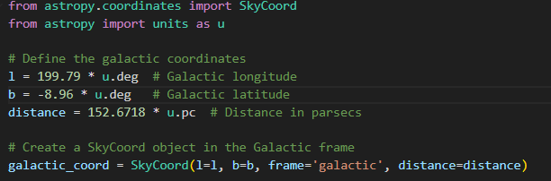
This setup demonstrates how Astropy integrates units and coordinate frames seamlessly, providing a robust platform for astrophysical calculations.

3.1 Conversion to Cartesian Coordinates
Astropy facilitates the conversion from spherical (galactic) coordinates to Cartesian coordinates, providing a basis for further transformations:
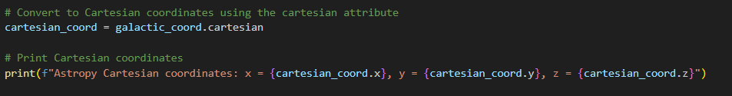
This step is critical as Cartesian coordinates simplify the application of geometric and algebraic operations necessary for subsequent coordinate frame transformations.

3.2 Transformation to Equatorial Coordinates
The Cartesian coordinates are transformed into the equatorial system (ICRS) using Astropy’s transformation capabilities:
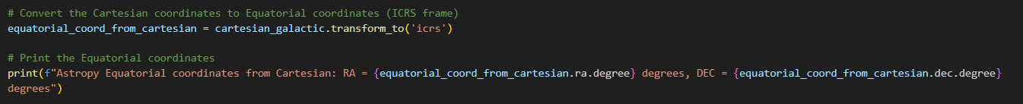
Astropy uses predefined rotation matrices that adhere to celestial coordinate transformation conventions, reflecting the alignment and tilt differences between the galactic plane and the celestial equator.

3.3 Reversibility and Verification
The accuracy and reversibility of conversions are verified by transforming the coordinates back to the original galactic system:
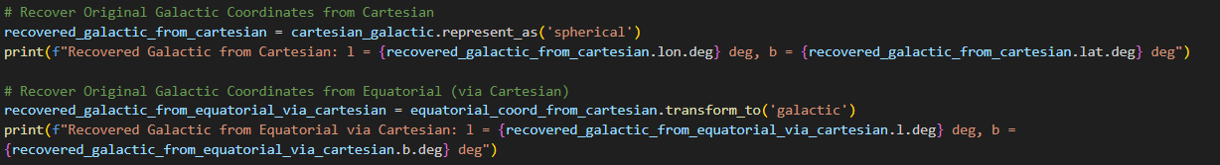
This step is essential to ensure that transformations can be reversed without loss of information, validating the integrity of the transformations for practical applications.

3.4 Direct Conversion and RA/DEC Conversion
Astropy also supports direct transformations between coordinate systems, simplifying the workflow for applications that frequently interchange between coordinate frames:

Additionally, the conversion of RA and DEC from traditional formats to decimal degrees is handled through a custom function, integrating these values into systems requiring decimal degrees:
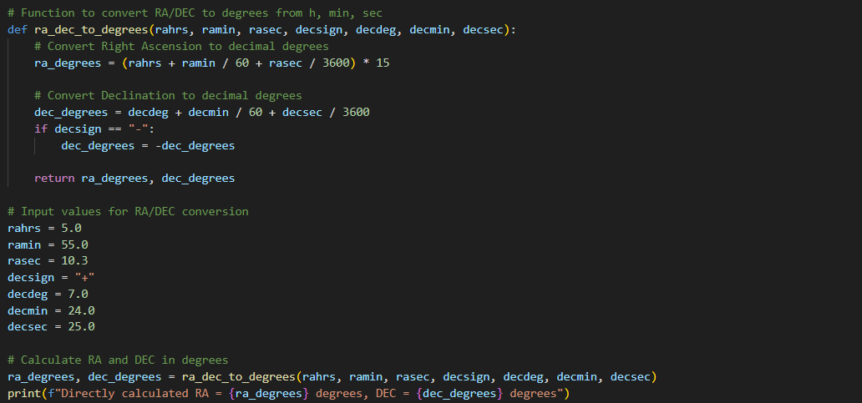

Finally, the full circle conversion is completed and all the results are printed out as demonstrated in the figure below
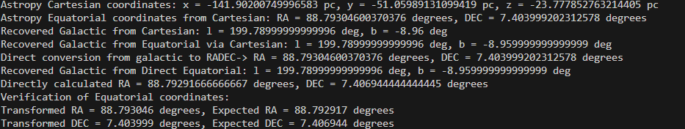

The study successfully demonstrates the effective use of Astropy for converting between galactic and equatorial coordinates, with a focus on the accuracy and reversibility of these transformations. The ability to reliably transform and verify celestial coordinates supports the integrity of astronomical data, which is crucial for the development of interactive applications such as stereographic projections and educational tools in astronomy. Through the integration of mathematical precision and the versatile tools provided by Astropy, this methodology offers a comprehensive framework for celestial coordinate transformations.

3.5 Discrepancies in Cartesian Coordinates when converted from Galactic frame and the Equatorial frame

3.5.1 Transformation Discrepancies Overview

In the complex field of astrometry, the conversion of celestial coordinates across different systems invariably results in discrepancies due to the fundamental differences in these systems. For example, when the same celestial object is represented in both equatorial and Galactic coordinates, the derived Cartesian coordinates will differ. This section examines why and how these differences manifest by focusing on transformations using two primary systems: the equatorial coordinate system, centered around Earth's rotational axis, and the Galactic coordinate system, aligned with the Milky Way's plane.

3.5.2 Theoretical Foundations and Mathematical Representation

The equatorial coordinate system (RA/Dec) is based on the projection of Earth’s equatorial plane onto the celestial sphere, with Right Ascension (RA) measured from the vernal equinox and Declination (Dec) from the celestial equator. Conversely, the Galactic coordinate system (l/b) aligns with the Galactic plane, with longitude (l) originating at the Galactic center and latitude (b) measured from the Galactic equator upwards. The transformations between these systems entail rotational adjustments that can be mathematically expressed through transformation matrices.

3.5.3 Why Cartesian Coordinates Differ Between Coordinate Systems

The equatorial coordinate system (RA/Dec) and the Galactic coordinate system are oriented based on distinct celestial markers and planes:
- Equatorial System: This system is oriented relative to Earth's equator and rotational axis. The Right Ascension (RA) is analogous to longitude and is measured eastward along the celestial equator from the vernal equinox. The Declination (Dec) is analogous to latitude and is measured north or south from the celestial equator. This system's primary reference plane is the celestial equator, which is the projection of Earth's equator onto the celestial sphere.
- Galactic System: The reference plane for this system is the Galactic plane, which is aligned with the observable plane of the Milky Way Galaxy. The Galactic Longitude (l) starts at the Galactic center and measures along the Galactic plane, while the Galactic Latitude (b) measures angular distance above or below the Galactic plane.
To understand why coordinates differ, consider how each coordinate system describes the position of a point in 3D space:
- Spherical to Cartesian Conversion Formulas:
  - Equatorial:
𝑥=𝑟⋅cos(Dec)⋅cos(RA)
𝑦=𝑟⋅cos(Dec)⋅sin(RA)
𝑧=𝑟⋅sin(Dec)
Where r is the distance of the star in parsecs, Dec is the Declination of the star in degree, and RA is the right ascension of the star in Degrees
  - Galactic:
𝑥=𝑟⋅cos(𝑏)⋅cos(𝑙)
𝑦=𝑟⋅cos(𝑏)⋅sin(𝑙)
𝑧=𝑟⋅sin(𝑏)
Where r is the distance of the star in parsecs, b is the galactic latitude in degrees and l is the galactic longitude in degrees.

3.5.4 Geometric Interpretation of Transformations
The above equations clearly demonstrate that even though the same star, such as Betelgeuse, is described in both systems, the actual Cartesian coordinates will differ because:
- Different Origins: RA/Dec is based on Earth's rotation and orbit around the Sun, meaning the origin and perspective are Earth-centered and aligned with Earth's axes. Conversely, Galactic coordinates take a more universal approach by aligning with the Galactic center, not Earth.
- Different Reference Planes: The celestial equator and the Galactic plane are inclined to each other at about 62.6 degrees, which means that the same physical point in space will have different coordinates under transformations associated with these tilted reference planes.
- Different Zero Points: RA is measured from the vernal equinox, while Galactic longitude is measured from the center of the Milky Way. This affects how angles (RA and l) are computed and interpreted in 3D space.
Therefore, the reason why the coordinates differ significantly across the two systems lies in the inherent geometrical and orientation differences of the reference planes used to define these systems. Transformations between these systems involve rotational adjustments that realign the coordinates according to their respective planes and origins, leading to different Cartesian coordinates for the same celestial object. These differences underline the importance of context and purpose when choosing a coordinate system for astronomical analyses.

3.5.5 Astropy Implementation to prove coordinate discrepancies

To implement these transformations using Astropy, the following Python code snippet can be employed, demonstrating the conversion from equatorial to Galactic coordinates and subsequently to Cartesian coordinates for the star Betelgeuse, the attributes used here: Right Ascension, Declination and Distance are extracted from the Bright Star Catalog.
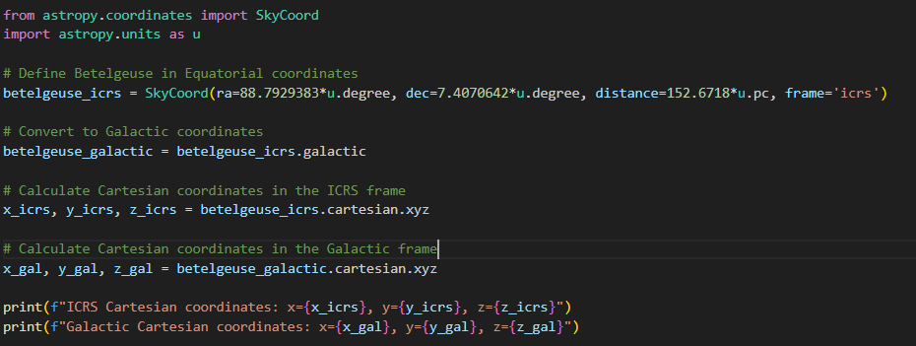

The discrepancies in the results are shown below

4.0 Performance Testing

4.1 Objective
The objective of this performance test is to evaluate the scalability and efficiency of the Astropy methos in handling full-circle conversions between Galactic coordinates and Cartesian coordinates via Equatorial coordinates.

4.2 Data Preparation
Range of Data Sizes: The test iterates over data sizes ranging from 10,000 to 1,000,000 stars, increasing in steps of 100,000 stars. This broad range tests the methods' performance under both light and heavy computational loads.
Randomization of Input Data: For each iteration, a new set of random galactic coordinates and distances is generated. This ensures that each test is performed on unique data, thus preventing any caching mechanisms or optimization shortcuts from influencing the results. This randomness is crucial for a fair evaluation of the performance characteristics.

4.3 Tools and libraries used
- Astropy: Chosen for its specialized celestial coordinate transformation capabilities, ensuring accuracy and adherence to astronomical standards.
- Matplotlib and Tqdm: Used for visualization and progress tracking, enhancing the clarity and usability of the test output.

4.4 Results
